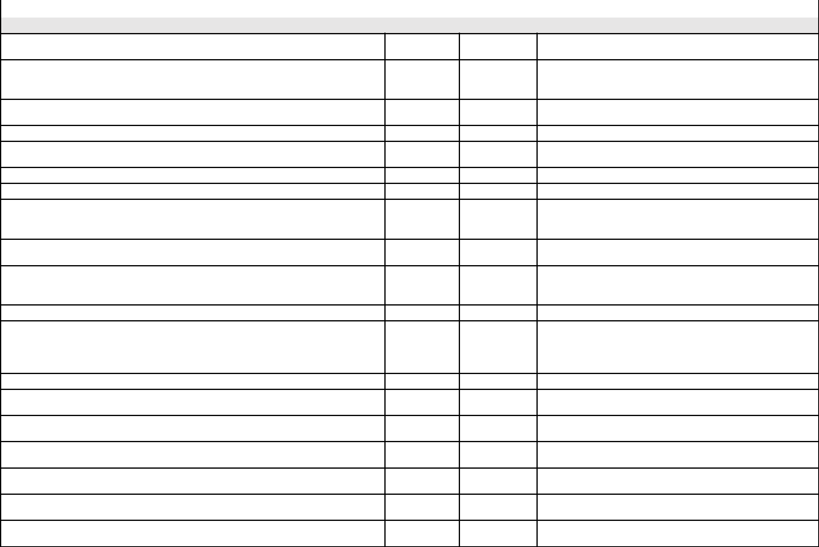

Document Management Software (DMS) Requirements | Standard | Optional | Comments
Key System Requirements

The DMS is a highly available, scalable platform on which to support a library containing

millions of files and documents.

All Administrative functionality can be accessed remotely using a web browser over the

internet, or through the companies LAN or WAN. SSL and VPN support further secure remote

user and administrator access.

The network operating system under which the DMS runs must be Windows 2008 R2 server

based or higher.

The network operating system under which the DMS runs must be Windows-based.

The DMS desktop client must be fully certified with Windows 7 or higher in a managed

environment.

Allows for enterprise licensing model.

Allows for concurrent and named user licensing.

The DMS provides both full user licenses for users to add, edit, and delete documents in the

system, as well as limited user licenses to restrict document access to read-only status. These

limited licenses will also be restricted from processes such as workflow.

The DMS must have a tool that checks server configuration and health settings to ensure the

document repository is running properly and without errors.

The DMS has HTML 5-based mobile client which allows users to access documents, add files,

and approve and review workflow tasks using a smartphone or tablet.

The DMS must provide the ability for a user to work "offline".

The system administrator has the ability to centrally control how the system works for users. A

system administrator can set the default value for the end users, which they may change, or

the settings can be “enforced” meaning that the end users cannot modify the option.

The DMS allows for easily resetting a user password.

The system allows the configuration of multiple balanced storage repositories to allow scalable

growth.

The DMS is capable of exporting documents out of a test system and importing into a

production system.

The DMS is fully integrated with Microsoft Office applications (Word, Excel, PowerPoint,

OneNote, Visio, Outlook).

The DMS allows users to attach documents directly to outgoing e-mail using Microsoft Outlook.

The DMS provides a web browser, a desktop client and a mobile browser as standard features.

The DMS will have an optional document portal, where anonymous or named users can access

a web-accessible interface with extremely limited rights.

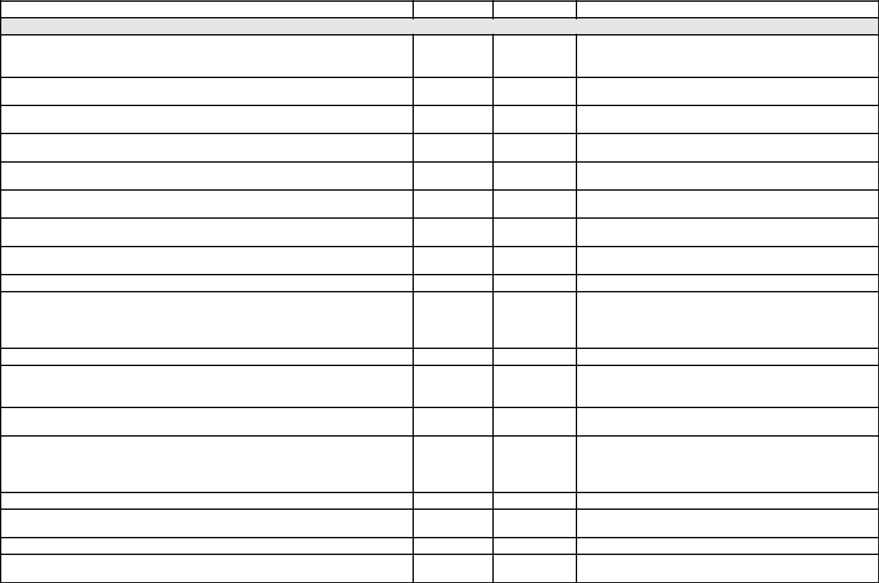
The DMS provides a wide variety of out-of-the-box reports on system usage.

Document Storage and Retrieval

The DMS has multiple methods to import existing documents from existing third party

applications, desktops, network drives and file servers. Importation can be done en masse.

The DMS has a headless server side document importation feature to import documents en

masse.

The DMS can store virtually any kind of document in its native file format, and ensure the

documents will not be altered when added to the system.

The DMS offers the option of adding documents as "records", which cannot be altered or

modified by users.

The DMS is capable of importing audio content files (MP3, wav, etc.) and launching appropriate

media viewers for retrieval.

Ability to capture, store, retrieve, and export irregular-sized (e.g., larger than 8 ½ x 11)

documents.

The DMS allows users to add emails along with their attachments. Attachments can be added

separately from emails, if required.

The DMS has the ability to track the location of hardcopy paper documents and physical

records. Physical documents can be located via search.

The DMS has the ability to "check out" both electronic document and physical records.

The DMS provides check in / check out ability, preventing documents from being overwritten or

deleted as documents are updated. The DMS librarian can review the status of all documents

checked out and check a document back in on behalf of another user.

The DMS automatically places all documents under version control.

The DMS has the ability to automatically increase the version number of the document upon

check in. Previous versions of documents are maintained by the system in the event that a

rollback is required.

The DMS has the ability to classify documents with metadata. The number of metatags and

document types should be practically unlimited.

The DMS ensures a mandatory amount of metadata is captured for each document or record in

the library. As new documents are added, the user is prompted to classify the file using

required metadata fields as defined by the controlled vocabulary, menus, and text fields.

The DMS has the ability to force users to update a metadata field value upon check in.

The DMS has the ability to process Microsoft Word and PDF electronic forms and automatically

extract metadata values.

The DMS can capture metadata from text on documents with visual tools.

The DMS offers "matter centric filing", or the ability to automatically tag documents (add

metadata) simply by dragging the documents into a folder, as used in legal filing.

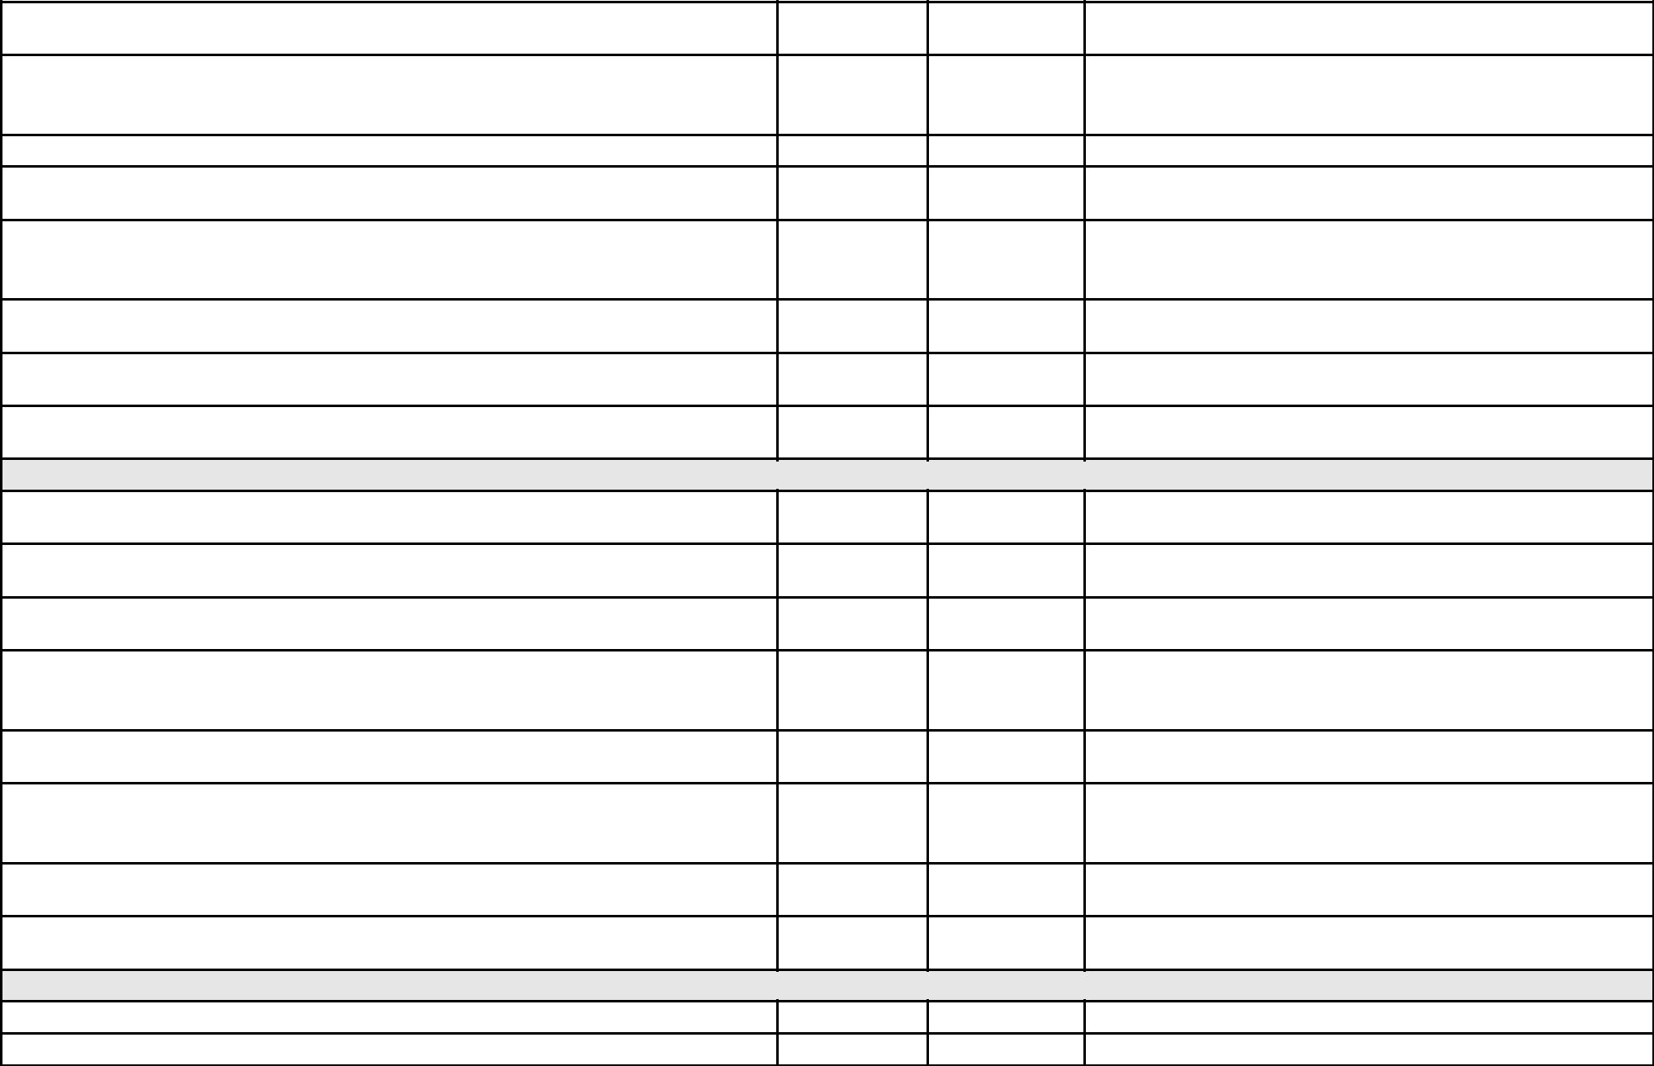
The DMS has the ability to create and print specialized document and version control numbers

on engineering or R&D documents.

The DMS provides adherence document and record naming conventions or standards. As

documents are added to the library, they are automatically renamed according to the naming

pattern determined by the Library Administrator.

The DMS offers electronic signature management via workflow.

The DMS allows users to subscribe to be notified of edits / changes / version updates to

documents or folders they are watching.

When an existing subscribed file is updated or a file is added to a folder, the user receives email

notification that the change has occurred, who has changed it, and a secure link to directly

access the document.

The DMS has the ability to send notifications for documents when specific dates are met.

Retention polices for converting to a record, archiving, and deletion can be set on a document

type and done automatically based on a determined date.

The DMS will provide the option of archiving documents that can be accessed as needed.

Document Security

The DMS allows navigational security, with multiple layers of user-definable security, to limit

access at department, user, system, function, and document levels.

The DMS has a role based security model where access can be given to users from a level of

read-only to system administration.

Role-based security model includes ability to establish exceptions. Additionally, access can be

limited to “read only” at the user level.

The DMS can send secure links to documents directly to team members, partners, suppliers, or

customers. File security is maintained as only authorized users can retrieve the file by using the

link.

The DMS allows administrators to block users from emailing a document as an attachment

from the DMS.

The DMS records a detailed permanent audit log of all actions performed on a document

including user and time stamp. These logs can be exported as reports as needed.

User roles will be used to determine the individual user's ability to delete documents in the

system.

Documents accidentally deleted by users (with delete permissions) can be easily recovered

from a "recycle bin".

Interface

The interface must be easy to use and familiar to users of a Windows environment.

The interface can be used with minimal mouse clicks and menu selection.


The user will be able to trigger actions through contextual menus that can be activated through

onscreen buttons, menu, or mouse.

The interface will provide help buttons to assist users with information relevant to what they

are looking at onscreen.

The system will provide the user interface in English, French, or Spanish.

The DMS provides the ability to personalize user preferences, views, alerts, workflow

notification preferences, and folder colors.

The DMS allows users to combine and aggregate files into their own personal "virtual" folders.

For example, a Project Manager might have a folder for project documentation, project legal

contract documents, invoices, design documentation and emails from their customer all in one

"virtual" folder, even though each individual piece of information is stored in various locations

throughout the library. These "virtual folders" can be shared with other users.

The DMS has the ability to create bookmarks to documents frequently accessed, such as a "My

Favorite" list.

The DMS has document-to-document linking to allow users to bundle files into logical groups

and integrated viewing capability to display all linked files screen. User can point and click on

the linked file and the system will take user to that record set.

Document Management Software (DMS) Requirements | Standard | Optional | Comments
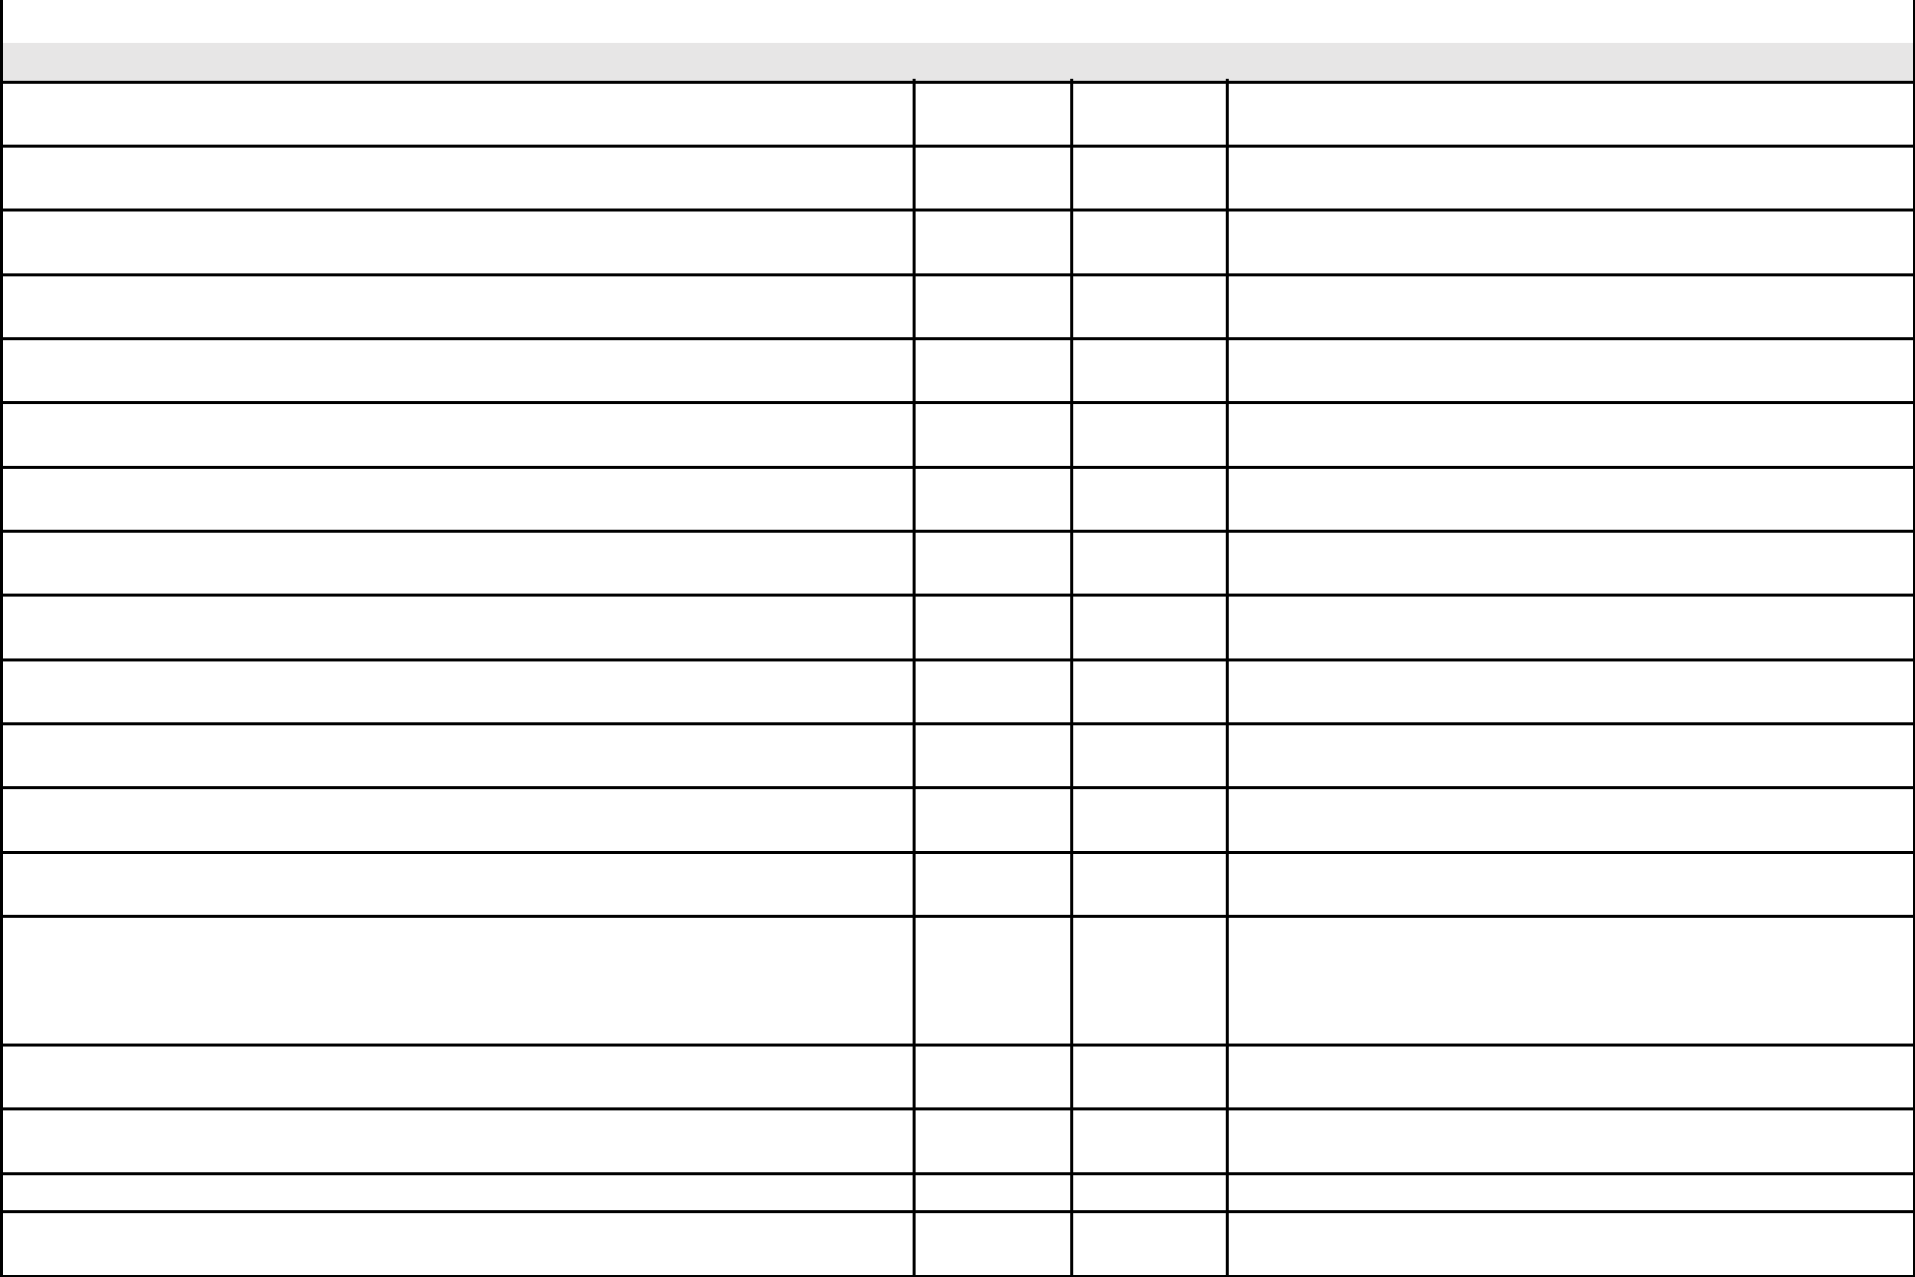
Searching

The DMS offers a web-based, mobile-based, and desktop clients for document searching.

The DMS search capability can search the metadata associated with the document as well as

the content of the document.

The DMS search capability can be configured to only search document metadata and exclude

document content.

The DMS search capability has the ability to index and search the content from several file

types with text layers, including pdf, zip, and Microsoft Office products.

The DMS search capability can be restricted to a specific area of the library (e.g. cabinet or

folder).

The full text search capabilities supports fuzzy, synonym, phonic, Boolean, wild card, phrase,

and proximity searches.

The DMS search capability must index document file properties such date added to system,

document owner, size, format, and file type.

The DMS can export search results and import them into an analysis tool, such as Microsoft

Excel.

Users can only search for and find (retrieve) find documents they are authorized to access.

The DMS has the ability to save searches for re-use. These searches can be made public for

use by others or private for use by only the user.

Saved Searches allow the user to change one or more search criterea as needed to make the

saved search a search template.

The DMS must be able to search the library from third party software by use of a shortcut

key.

For text fields, the retrieval software should permit index searches based on exact or partial

matches of specified field values.

For numeric fields, the retrieval software should permit index searches based on ranges of

field values specified by the following relational expressions: equals, does not equal, greater

than, less than, greater than or equal to, less than or equal to, between, at least, and no

older than.

Ability to retrieve documents by document title, classification, type, address, customer

name, number, or any other user-defined index value.

Search results should be displayed in a simple list, with ranking by relevancy. Documents can

be accessed directly in the search interface.

The DMS has the ability to highlight search results in the viewer.

The DMS can recognize pdf and tiff documents without a text layer and OCR them so that

they are fully searchable.


Ability to retrieve documents using multiple index words, numbers, dates, etc.,

simultaneously.

The system should accommodate the inclusion or exclusion of previous document versions

and archived documents from search results.

While using the search, users should be able to perform basic document management tasks -

such as editing metadata, linking to other documents, or checking documents out - that can

be performed in the other areas of the DMS.

The DMS has the ability to search directly in the Microsoft SQL database.

The DMS has the ability to report on the full text search engine and send notifications to

administrators if there are any issues.

The DMS has the ability to configure the search engine.

The DMS has the ability to log all searches conducted in the system.

The DMS has the ability set the maximum number of search results.

Document Management Software (DMS) Requirements | Standard | Optional | Comments
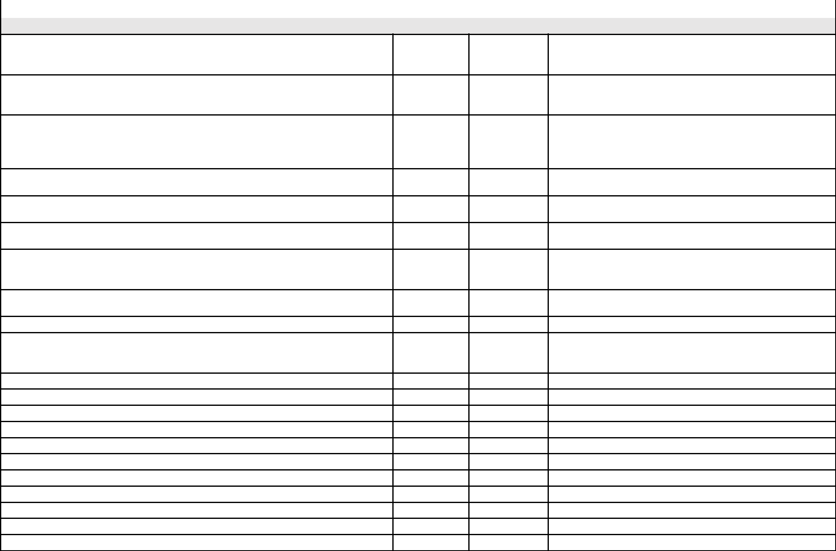
Workflow

The DMS provides a document review and approval workflow for documents needing to pass

through several authors, reviewers and approvers before being ready for general distribution.

Users can quickly create staging and collaboration areas for documents as they are being

worked on. Once reviewed and approved, documents can be moved or linked to publishing

folders for wider spread distribution.

The document approval workflow allows documents to be sent to one or many users for sign

off. Approvers are able to approve or reject the document, providing comments and feedback

where required. A sign-off sheet for each document version is maintained so users can see who

approved or rejected the document and the feedback they provided.

Workflow tasks should be easily delegated in the event that a participant is no longer available

to complete the task.

Individual document versions can be restricted from broader circulation until they have been

approved by appropriate parties.

Provides the ability to delegate review and/or approve tasks and signing authority to other

users for individual tasks or for all tasks over a given time period.

The workflow allows specific users to act as observers of review or approval workflows.

Observers can track the progress of documents as they proceed through the workflow and view

any comments and feedback as its provided.

The status of a workflow (review, approved, not approved, pending approval, not submitted for

approval) can be easily searched.

The date of review or approval of a document can be easily searched.

Users participating in review or approval workflows are provided with a personalized task list

for all tasks assigned to them. Users can see at a glance their tasks, a description of the work to

be done, who assigned the task and it needs to be completed.

Assigned workflow tasks are sent as email notifications.

Workflow allows users to define conditions.

Workflow must provide support for ad-hoc and rules-based workflows.

Workflow can be automated for a specific document type and workflow template.

Workflow creates an audit trail.

Workflow includes electronic signature capabilities.

The DMS workflow must integrate with Adobe Sign.

Workflow tasks can be viewed in a calendar.

The workflow can automatically start when a document is added.

The workflow can be restarted automatically or manually.

Administrators are able to clone a workflow template.

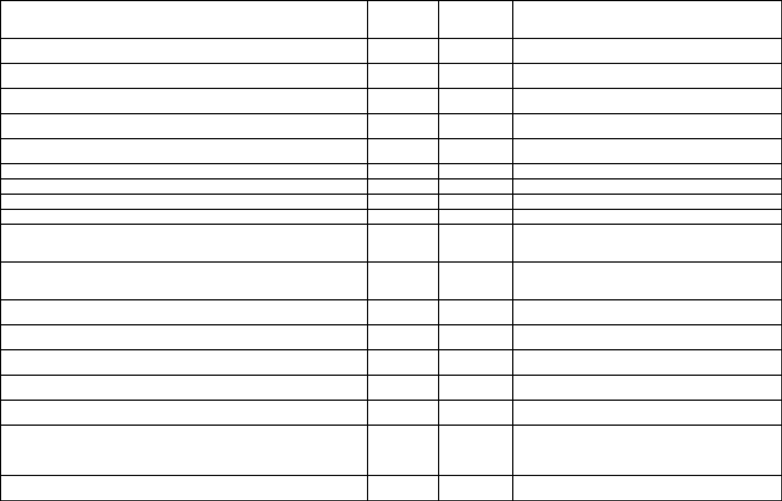
The workflow has the ability to postpone the approval of a document in the event that not

enough information is provided to approve the document or needs to be sent back to a

previous step in the workflow process.

The workflow allows a task to be assigned to a group of users where all participants must

complete the task or only one in the group must complete the task.

For the task due by time, the number of hours and/or days or a specific date and time can be

specified.

The workflow should alert users when tasks are overdue. These alerts can be repeated at

regular defined intervals.

A document under a workflow process can be checked out and modified by a participant in the

active workflow activity.

Several documents can be included in a single workflow and can be approved in a single step.

The workflow should have the ability to insert an activity 'on the fly'.

Any changes made to the workflow are recorded in a change log.

The statuses of workflows should be viewable through a dashboard.

The workflow history must be maintained for all document versions.

The DMS must support an external workflow feature to allow documents to be sent to external

users for viewing or approving. These approvals will be part of the audit trail for documents.

Documents sent to external users to be sent via secure transmission links. These links can have

a required viewing timeline, can be rescinded, and will record time of document viewing,

download, and review or approval.

The DMS allows administrators to determine which users are permitted to send documents to

external users via transmission.

Documents sent to external users can be viewed and approved using web browsers, and do not

require the recipient to install new software.

Documents sent to external users for approval can require a recipient-defined password for a

digital signature on documents.

External recipients of transmitted documents can be restricted from downloading the

document and be given a "view only" option.

The web-based viewing platform for viewing or approving externally-transmitted documents

must be viewable easily on mobile devices.

All elements of external transmission must be logged as part of the audit trail; user initiation,

document transmission, successful receipt, and any steps performed must be logged with the

date and time and recalled as part of the unalterable reporting record of activities.

Document transmission to external sources can be configured as a verified source through

purchase of a SSL certificate.

Document Management Software (DMS) Requirements | Standard | Optional | Comments

Document Viewer Functionality

The viewer allows users to look at certain types of files without having the native

software installed, such as image, PDF, and Microsoft Word documents.

The viewer provides the ability to print out a document.

The viewer can have multiple files open at the same time.

Ability to manipulate image displays by scaling, magnifying, or panning.

The viewer has the ability to add, remove, or move pages.

The viewer provides the ability to save a document locally.

The viewer has the ability to publish new documents or new versions into the library.

The viewer can automatically show documents in folder and search results.

The viewer has the ability to highlight search results.

The viewer has the ability to assemble new PDF documents based on existing

documents in the library and append or prepend pages to the new document.

The viewer must be available in both desktop and web versions of the client.

The viewer allows a user to do annotations on documents without having to open

them in native software. The annotated documents can be saved as a new version.

Document Management Software (DMS) Requirements | Standard | Optional Comments

Integration and Customization

The DMS integrates with Microsoft SharePoint to give users access to documents in both

locations.

The DMS synchronizes users or groups from objects in Active Directory, LDAP or NT Domain

directory servers. Once integrated, both users and groups can then be assigned to functional

roles.

The DMS should have an industry-standard, fully-documented API that allows integration with

third party applications.

The DMS integrates with Microsoft SQL Reporting Services to generate an infinite array of

reports.

The DMS interfaces a virtual printer to allow adding of documents from any Windows-based

application with the print function.

The DMS allows for the expansion of document repositories while remaining seamless to the

user.

The DMS can be "localized".

The DMS can be rebranded.

The DMS can be customized so that appearance resembles that of an organization's own look

and feel.

The DMS has a "portal" in which casual users can access specially designated information in the

library without having the need to login. These users would be restricted to "read-only" access.

The DMS can take documents and file them into appropriate folders based on predefined

values in customized scripts.

The DMS can integrate with multiple data providers such as ODBC, OLE DB, Oracle and SQL

Server to single-source metadata.

The system has schema level database lookups that allows a query to be executed on an

external database to retrieve additional values that are mapped to the other metadata fields in

the schema.

The DMS has a importing tool that can perform server side lookup of metadata or perform a

lookup of metadata from another database.

The system has the ability to bring emails into library automatically from Microsoft Outlook.

The DMS can execute searches of the library while in third party Windows applications through

keystroke combinations.

The DMS must support two-factor authentication.

The DMS must integrate with Microsoft Office applications.

The DMS must be FIPS-140 (US Federal Information Processing Standards) compliant.

Document Management Software (DMS) Requirements | Standard | Optional Comments


Document Scanning

The DMS provides either a built-in scanning tool or third party scanning software that

seamlessly integrates with the DMS.

The DMS supports both simple and complex scanning.

The DMS is configurable to watch for files created by the scanning process and streamline the

indexing and addition of scanned files to the library.

The DMS is compatible with desktop and production scanners.

The DMS provides the ability to import images and indexes provided by third party scanning

software.

Scanned documents with a searchable text layer are indexed and searchable.

The DMS interfaces with a network facsimile system.

The DMS has the ability to recognize PDF and Tiff documents without a text layer and OCR

them.

The DMS has the ability to do web-based scanning.

The web-based scanning software can zoom, rotate, deskew, and move through document

pages.

The web-based scanning software can upload documents to the library.

Documents scanned with third party scanning software must have the ability to import

documents into DMS along with any values that were zonally OCR'd to populate metadata field

values.

Supplied third party scanning software must have the ability to automate the capture of data

from documents.

Supplied third party scanning software must have the ability to manipulate document page

layout, split documents, move pages, and perform image cleanup.

